Software Requirement Specifications

Project Code: CRM-Online

Document Code: CRM_SRS_v.1.0

Vietnam, 01 2011



Record of change

*A - Added M - Modified D - Deleted
Effective Date | Changed Items | A*  M, D | Change Description | New Version
Jan 13, 2010 |  | A | Khởi tạo tài liệu SRS | 0.1

SIGNATURE PAGE

AUTHOR: Name: FPT Software Signature:
Title: Date:

REVIEWERS: Name: ___________ Signature:
Title: Date:

APPROVAL: Name: ___________ Signature:
Title: Date:

Name: Signature:
Title: Date:

Table of Contents
Contents
Ngân hàng Tiên Phong 1
Hệ thống quản trị quan hệ khách hàng 1
Software Requirement Specifications 1
Project Code: CRM-Online 1
Document Code: CRM_SRS_v.1.0 1
Record of change 2
SIGNATURE PAGE 3
Table of Contents 4
1.1. Purpose 7
1.2. Definitions, Acronyms, and Abbreviations 7
1.3. References 7
2. High Level Requirements 8
2.1. Product Perspective 8
2.2. Actors and Use Cases Descriptions 9
2.2.1. Diagram 9
2.2.2. Actors Description 14
2.2.3. Use Cases Description 14
2.2.4. Use Case & Actor mapping 15
2.3. Operating Environment 17
2.4. Assumption and Dependencies 17
3. Functional Requirements 17
3.1. Module 01 17
3.1.1. UC01: Login 17
3.1.2. UC02: List users in a devision 18
3.1.3. UC03: Search users 19
3.1.4. UC04: View details user 19
3.1.5. UC05: Add new user 20
3.1.6. UC06: Edit user 21
3.1.7. UC07: Delete user 22
3.1.8. UC08: List devisions 23
3.1.9. UC09: View detail devison 23
3.1.10. UC10: Add new devision 24
3.1.11. UC11: Edit devision 25
3.1.12. UC12: Delete devision 25
3.2. Module 02 26
3.2.1. UC13: Search customers 26
3.2.2. UC14: View detail customer 27
3.2.3. UC15: View customer histories 27
3.2.4. UC16: Add new customer 28
3.2.5. UC17: Edit customer 29
3.2.6. UC18: Delete customer 30
3.2.7. UC19: List used services 30
3.2.8. UC20: Add new used services 31
3.2.9. UC21: Update used services 32
3.2.10. UC22: Approve change 32
3.2.11. UC23: Nhập dữ liệu - Tình hinh SXLD 33
3.2.12. UC24: Nhập dữ liệu – Quan hệ với các tổ chức tín dụng 34
3.2.13. UC25: Nhập dữ liệu – Lịch sử tiếp xúc 35
3.2.14. UC26: Edit dữ liệu - Tình hinh SXLD 35
3.2.15. UC27: Edit dữ liệu – Quan hệ với các tổ chức tín dụng 36
3.2.16. UC28: Edit dữ liệu – Lịch sử tiếp xúc 37
3.2.17. UC29: Details View – Tình hình SXKD 38
3.2.18. UC30: Details View – Quan hệ với các tổ chức tín dụng 39
3.2.19. UC31: Details View – Lịch sử tiếp xúc 40
3.2.20. UC32: Duyệt TXKH – Approve 40
3.2.21. UC33: Duyệt TXKH – Reject 41
3.2.22. UC34: Duyệt TXKH – Cancel 42
3.2.23. UC35: Xóa – Quan hệ với các tổ chức tín dụng 42
3.2.24. UC36: Xóa – Lịch sử tiếp xúc 43
3.3. Module 03 44
3.3.1. UC37: Báo cáo theo CIF 44
3.3.2. UC38: Báo cáo theo ĐVKD 45
3.3.3. UC39: Báo cáo toàn bank 45
3.3.4. UC40: Lấy thông tin từ TPB 46
3.3.5. UC41: Validation user AD 47
3.3.6. UC42: Check user AD 48
3.3.7. UC43: Define categories 48
3.3.8. UC44: 49
4. Mockup Screens 50
4.1. SC01: Login 50
4.2. SC02: List users in a devision 50
4.3. SC03: Search users 52
4.4. SC04: View details user 52
4.5. SC05: Add new user 53
4.6. SC06: Edit user 53
4.7. SC07: Delete user 54
4.8. SC08: List devisions 54
4.9. SC09: View detail devison 55
4.10. SC10: Add new devision 56
4.11. SC11: Edit devision 56
4.12. SC12: Delete devision 57
4.13. SC13: Search customers 57
4.14. SC14: View detail customer 58
4.15. SC15: View customer histories 58
4.16. SC16: Add new customer 59
4.17. SC17: Edit customer 59
4.18. SC18: Delete customer 61
4.19. SC19: List used services 62
4.20. SC20: Add new used services 62
4.21. SC21: Update used services 63
4.22. SC22: Approve change 64
4.23. SC23: Nhập dữ liệu - Tình hinh SXLD 65
4.24. SC24: Nhập dữ liệu – Quan hệ với các tổ chức tín dụng 66
4.25. SC25: Nhập dữ liệu – Lịch sử tiếp xúc 67
4.26. SC26: Edit dữ liệu - Tình hinh SXLD 68
4.27. SC27: Edit dữ liệu – Quan hệ với các tổ chức tín dụng 69
4.28. SC28: Edit dữ liệu – Lịch sử tiếp xúc 70
4.29. SC29: Details View – Tình hình SXKD 70
4.30. SC30: Details View – Quan hệ với các tổ chức tín dụng 71
4.31. SC31: Details View – Lịch sử tiếp xúc 71
4.32. SC32: Duyệt TXKH – Approve 72
4.33. SC33: Duyệt TXKH – Reject 74
4.34. SC34: Duyệt TXKH – Cancel 76
4.35. SC35: Xóa – Quan hệ với các tổ chức tín dụng 77
4.36. SC36: Xóa – Lịch sử tiếp xúc 77
4.37. SC37: Báo cáo theo CIF 78
4.38. SC38: Báo cáo theo ĐVKD 79
4.39. SC39: Báo cáo toàn bank 80
4.40. SC40: 80

Introduction

Purpose
This Software Requirements Specification provides a complete description of all the functions and specifications of the CRM project developing Customer Relationship Management System. This document is intended to be used by the members of the project team that will implement and verify the correct functioning of the system.

Definitions, Acronyms, and Abbreviations

# | Abbreviations/Terms | Explanation
1 | SRS | Software Requirement Specification
2 | BR | Business Rule
3 | SC | Screen
4 | UC | Use Case
Table 1: Abbreviations & Terminologies

References

# | Name | Description
Table 2: Reference

High Level Requirements

Product Perspective

This application is integrated into eHTi which can also operate independently, shall offer a unified place for the MHA officers to find, communicate with, manage people and their permissions, including support for custom fields such as area of focus, specialty, language proficiency etc.

Actors and Use Cases Descriptions

Diagram
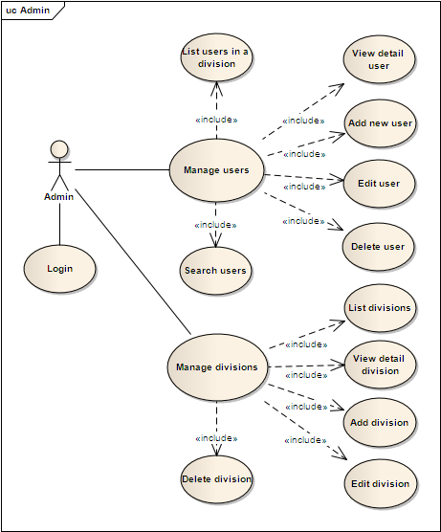

Diagram 01 – Admin roles

Diagram 02 – Quản lý thông tin khác hàng

Note: ESD admins can access to ALL functions

Diagram 03 – Quản lý báo cáo tiếp xúc KH

Diagram 04 – Quản lý báo thu nhập KH

Diagram 05 – Sơ đồ trạng thái báo cáo TXKH

Actors Description
# | Actor Name | Definition & Interests
1 | Admin
2 | Division Leader
3 | Staff
4 | BOD
5 | System

Use Cases Description
# | Code | Name | Brief Description
1 | UC01 | Customer Login | Cho phép actor đăng nhập vào hệ thống
2 | UC02 | Customer Logout | Cho phép xác định quyền truy cập so với hệ thống AD
3 | UC03 | View Product
4 | UC04 | Create Order
5 | UC05 | Create Feedback
6 | UC06 | Payment
7 | UC07 | Register
8 | UC08 | Edit Profile
9 | UC09 | Vote
10 | UC10 | Search
11 | UC11 | Add to Cart
12 | UC12 | View help
13 | UC13 | View History Order
14 | UC14 | Create Customer
15 | UC15 | View Customer
16 | UC16 | Update Customer
17 | UC17 | Delete Customer
19 | UC18 | Create Order
20 | UC19 | View Order
21 | UC20 | Update Order
22 | UC21 | Delete Order
23 | UC22 | Create Product
24 | UC23 | View Product
25 | UC24 | Update Product
26 | UC25 | Delete Product
27 | UC26 | Create Customer
28 | UC27 | Input Flower to store
29 | UC29 | View flower in store
30 | UC30 | Admin Login
31 | UC31 | Admin logout
32 | UC26 | Admin change pass
33 | UC27
34 | UC28
35 | UC29
36 | UC30
37 | UC31
38 | UC32
39 | UC33
40 | UC34
41 | UC35
42 | UC36
43 | UC37
44 | UC38
45 | UC39
Table 3: Use Case List

Use Case & Actor mapping
Actor  Use Case | Admin | Devision Leader | Staff | BOD | System
UC01: Login | x | x | x | x
UC02: List users in a devision | x
UC03: Search users | x

(*): Anonymous user can see wall of other user profile

Operating Environment

Assumption and Dependencies

Functional Requirements

Module 01

UC01: Login

Use Case Description
Name | Login | Code | UC01
Description | Cho phép actor đăng nhập vào hệ thống
Actor | Admin/Devision Leader/Staff/BOD | Trigger | Actor bấm nút login
Pre-condition
Post condition | Chuyển tới trang default với role tương ứng

Activities
Actor |  | System
Main Flow: Login thành công
1 | Actor nhập tên đăng nhập/mật khẩu và click vào button Login trên trang đăng nhập (SC01).
 |  | 2 | Kiểm tra tên đăng nhập/mật khẩu là chính xác sau đó chuyển tới trang default role tương ứng (SC03, SC02...)

Business Rules
Rule No. | Rule | Description

System Message
MS01 | “Tên Đăng Nhập và/hoặc Mật Khẩu của bạn không chính xác. Vui lòng kiểm tra và thử lại.”  Mesage thông báo khi actor nhập sai tên đăng nhập/mật khẩu

UC02: List users in a devision

Use Case Description
Name | List users in a devision | Code | UC02
Description | Cho phép actor view toàn bộ users trong hệ thống
Actor | Admin | Trigger | Load trang quản lý users
Pre-condition | Actor đã đăng nhập vào hệ thống
Post condition | View danh sách toàn bộ users trong hệ thống

Activities
Actor |  | System
Main Flow: List users in a devision successfully
1 | Actor click vào sub menu item Quản lý người dùng/Quản lý thông tin
 |  | 2 | Load thông tin toàn bộ users có trong hệ thống, bind date vào gridview và hiển thị lên trang Quản lý thông tin người dùng (SC03).

Business Rules
Rule No. | Rule | Description
1 | Hiển thị Gridview | GridView hiển thị đúng dữ liệu, dữ liểu đảm bảo đã encode trước khi hiển thị, đảm bảo không vỡ trang khi dữ liệu quá dài.
2 | Ẩn Gridview | Ẩn Gridview khi không có dữ liệu.

System Message
N/A

Mockup Screens

SC01: Login

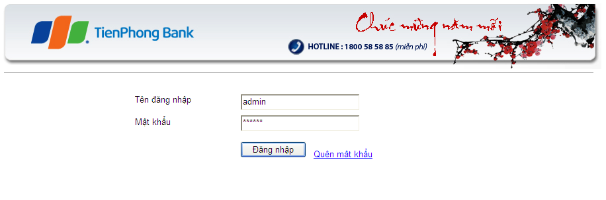

Figure 1 - Login

Data field
No | Item | Type | Description

SC02: List users in a devision

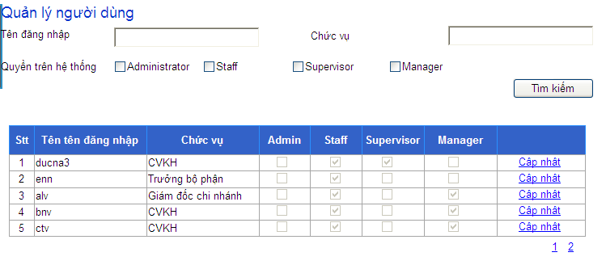

Figure 2 – List users in a divison

Data field
No | Item | Type | Description

SC16: Add new customer
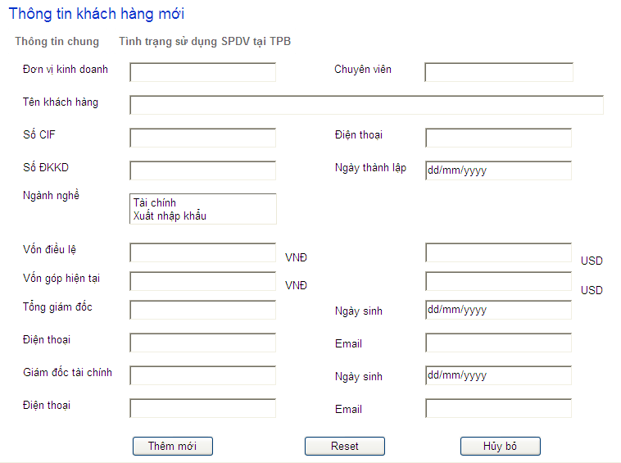
Figure 16 – Add new customer

Data field
No | Item | Type | Description

